**Objective of the Lab/Program**

This program calculates nCr, in that nCr = n! / ((n-r)! * r!). It will accept the numbers n and r from the user and calculate the factorial in a block. Should n < r it prints an error message and get the inputs n and r from the user again.

**Assembly Source Codes**

.data

str1: .asciiz "Please enter n: "

str2: .asciiz "\nPlease enter r: "

str3: .asciiz "\nn should not be less than r re-enter the values.\n"

str4: .asciiz "\nThe answer is: "

.text

j begin

again:

la $a0, str3

li $v0, 4

syscall

begin:

la $a0, str1

li $v0, 4

syscall

li $v0, 5

syscall

move $s0, $v0 #Contains the value of n

la $a0, str2

li $v0, 4

syscall

li $v0, 5

syscall

move $s1, $v0 #Contains the value of r

blt $s0, $s1, again #If N < R try again

#Defining Variables

move $t0, $s0 #Holds the value of n, will also be used to calculate factorial of a number

li $t1, 0 #contains the value of the top of the fraction

li $t2, 0 #Contains the value in the bottom left of the fraction

li $t3, 0 #Contains the value in the bottom right of the fraction

sub $t4, $s0, $s1 #make $t4 = n-r

li $t7, 0 #multiply value of factorial

move $t7, $t0

jal factorial

main:

move $t1, $t0 #Assign the value of top of fraction to n!

move $t0, $s1 #make $t0 r

move $t7, $t0 #make $t7 r which is then going to be r-1....

jal factorial #perform r!

move $t2, $t0

move $t0, $t4 #make $t0 = (n-r)

move $t7, $t0 #make $t7 (n-r)

jal factorial #perform n-r!

move $t3, $t0

mul $t5, $t3, $t2 #holds the finally value of the bottom fraction

div $t1, $t5

mflo $t6

la $a0, str4 #Prints the result

li $v0, 4

syscall

la $a0, ($t6)

li $v0, 1

syscall

j exit

factorial:

subi $t7, $t7, 1 #make $t7 = $t7-1

mul $t0, $t7, $t0 #$t0 * $t7

bgt $t7, 1, factorial #break if $t0 > 1

jr $ra

exit:

li $v0, 10 #terminate program

syscall

**Screen shot of the results**

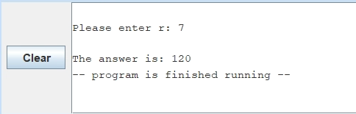

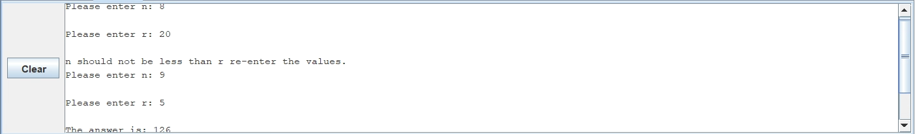

**Conclusion and References**

A label for calculating factorial was created and whenever it was called it was treated as a function. The program individually found the factorial of three separate values, n!, r! and (n-r)! then multiplied and divided the values accordingly to arrive at the result.